**Topics: Descriptive Statistics and Probability**

1. Look at the data given below. Plot the data, find the outliers and find out $μ, σ, σ^{2}$

|  |  |
| --- | --- |
| **Name of company** | **Measure X** |
| Allied Signal | 24.23% |
| Bankers Trust | 25.53% |
| General Mills | 25.41% |
| ITT Industries | 24.14% |
| J.P.Morgan & Co. | 29.62% |
| Lehman Brothers | 28.25% |
| Marriott | 25.81% |
| MCI | 24.39% |
| Merrill Lynch | 40.26% |
| Microsoft | 32.95% |
| Morgan Stanley | 91.36% |
| Sun Microsystems | 25.99% |
| Travelers | 39.42% |
| US Airways | 26.71% |
| Warner-Lambert | 35.00% |

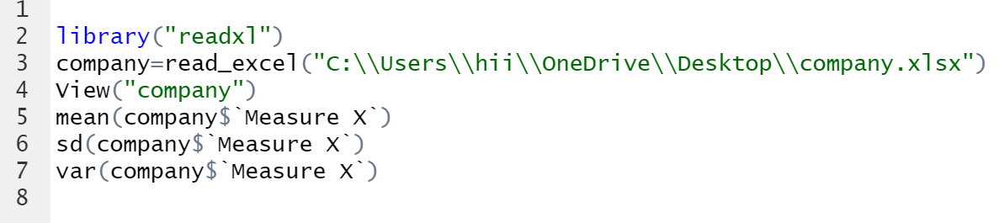

Mean = 33.2%

Standard Deviation ­= 0.1695

Variance = 0.028714661

**Boxplot(x=company$’Measure X’,horizontal=TRUE)**

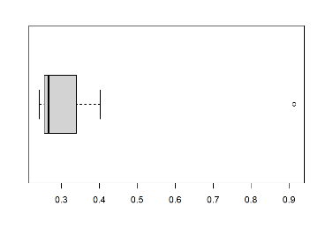

From the observations,There is only One outlier **MORGAN STANLEY 91.36%**



Answer the following three questions based on the box-plot above.

1. What is inter-quartile range of this dataset? (please approximate the numbers) In one line, explain what this value implies.

Ans-: IQR=UQ – LQ

=12 – 5 =7

1. What can we say about the skewness of this dataset?

Ans-This is positive skewed data

1. If it was found that the data point with the value 25 is actually 2.5, how would the new box-plot be affected?

Ans- The new boxplot will have no outliers in it



Answer the following three questions based on the histogram above.

1. Where would the mode of this dataset lie?

Ans- Mode of the data set lies on left side and 5-8

1. Comment on the skewness of the dataset.

Ans- As mass of distribution is concentrated on left side .it is positively skewed.

1. Suppose that the above histogram and the box-plot in question 2 are plotted for the same dataset. Explain how these graphs complement each other in providing information about any dataset.

Ans- : By comparing both of the data above it is clear that the data will be positively

Skewed and also gives us the mean and mode values.

1. AT&T was running commercials in 1990 aimed at luring back customers who had switched to one of the other long-distance phone service providers. One such commercial shows a businessman trying to reach Phoenix and mistakenly getting Fiji, where a half-naked native on a beach responds incomprehensibly in Polynesian. When asked about this advertisement, AT&T admitted that the portrayed incident did not actually take place but added that this was an enactment of something that “could happen.” Suppose that one in 200 long-distance telephone calls is misdirected. What is the probability that at least one in five attempted telephone calls reaches the wrong number? (Assume independence of attempts.)

Ans- : E: The call is misdirected

then probability of the event E is

P(E)= 1/200

Therefore,

Probability that at least one in 5 attempted call reaches the wrong number

= 1 - Probability that no attempted call reaches the wrong number

= 1 – P(E bar)

= 1 – (199/200)* (199/200)* (199/200)* (199/200)* (199/200)

= 1 - (199/200)^5

= 0.025

Probability that at least one in 5 attempted call reaches the wrong number = 0.025

1. Returns on a certain business venture, to the nearest $1,000, are known to follow the following probability distribution

|  |  |
| --- | --- |
| x | P(x) |
| -2,000 | 0.1 |
| -1,000 | 0.1 |
| 0 | 0.2 |
| 1000 | 0.2 |
| 2000 | 0.3 |
| 3000 | 0.1 |

1. What is the most likely monetary outcome of the business venture?

Ans- 2000 because p(x)=0.3 as it is the maximum probability.

1. Is the venture likely to be successful? Explain

Ans- Yes there is 60% of getting positive return and 20% of getting negative return or debts.

1. What is the long-term average earning of business ventures of this kind? Explain

Ans- Long term returns = ((-2000*0.1) + (-1000*0.1) + (1000*0.2) + (2000*0.3)+

(3000*0.1) = **800**

1. What is the good measure of the risk involved in a venture of this kind? Compute this measure

Ans- It is positive,as Long term returns is 800.